**EU Agencies committed to strengthening the fight against intellectual property crime**

24/01/2019

Today, the Heads of various EU Justice and Home Affairs (JHA) Agencies and the European Commission came together at Eurojust, the EU’s Judicial Cooperation Unit, for the 2nd high-level meeting on a joint strategy related to intellectual property (IP) crime, to strengthen interagency cooperation against IP crime and agree on new roles and concrete actions. One of the partners, the [European Union Intellectual Property Office (EUIPO)](https://euipo.europa.eu/ohimportal/en), is considering the possibility of providing financial support to Eurojust in cases involving IP crime, including the support of joint investigation teams (JITs). At present, there are six active JITs with EU partners and Member States. The direct and swift exchange of information between all JHA partners remains the key to more operational effectiveness and the successful prosecution of IP crimes.

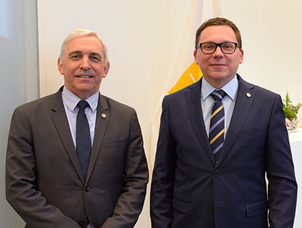Mr Ladislav Hamran, President of Eurojust, said: *‘As nowadays criminality has no borders, close cooperation between Eurojust and its trusted EU partners is more necessary than ever to investigate and prosecute IP crimes, bring criminals to justice and protect our fellow European citizens. I therefore heartily welcome today’s meeting as an excellent opportunity to draw valuable lessons learned, reinforce mutual trust and coordinate our common strategy.’*

Mr Christian Archambeau, Executive Director of the EUIPO, said: *‘In order for the IP system to deliver its expected benefits, we need a combination of efficient and accessible registration services and effective enforcement. High-level meetings of this kind, combined with the exchange of data and statistics, play an important role in ensuring that the EU provides a joined-up IP system that fosters creativity and innovation, protects citizens, and ultimately helps generate jobs and growth.’*

This year’s meeting was organised by EUIPO and hosted at Eurojust’s premises in The Hague. The meeting builds on the operational experience gathered since the previous meeting in January 2018, following which all partners involved (European Commission, Eurojust, Europol, EUIPO, the European Union Agency for Law Enforcement Training (CEPOL) and the European Anti-Fraud Office (OLAF)) adopted a cooperation framework to enhance the fight against IP crime in the European Union and beyond. The high-ranking participants reiterated the importance of improved data exchange and analysis, especially since the new legal framework for Eurojust and Europol unlocks the possibility of mutual indirect access to databases between the two agencies.